This access statement does not contain personal opinions as to our suitability for those with access needs, but aims to accurately describe the facilities and services that we offer all our guests/visitors.
Access Statement for Didcot Railway Centre
Please note: The Didcot Parkway Station Car Park is being redeveloped and the route to Didcot Parkway Station and Didcot Railway Centre may be affected by this work. We will review and publish a revised Access Statement when this work is complete. The Blue Badge parking outside Didcot Parkway Station is not affected.
Introduction
Didcot Railway Centre, situated in 22 acres beside Didcot Parkway Station, is the living museum of the Great Western Railway. The Centre has developed around the original 1930s Engine Shed complex and houses a collection of locomotives, carriages, wagons, buildings and memorabilia.
Visitors should be aware of an unavoidable flight of 18 steps on the only access route to the Centre. The Centre is 3/4 mile long and you should allow at least two hours to explore. There is a network of concrete paths and, once inside, level access to all areas. Didcot Railway Centre is a working museum so it is not always possible to make all parts and vehicles as accessible as we would like and our aim is to provide as much access as possible within those constraints. We can provide guided tours on major opening days and for booked parties of visitors.
Visitors can enjoy a range of hot and cold food in our Refreshment Room and buy souvenirs in our Shop.
We look forward to welcoming you. If you have any queries or require any assistance please phone 01235 817200 or email info@didcotrailwaycentre.org.uk.
Pre-Arrival
- Full details of how to reach us are on our website (How to get to Didcot).
- The entrance to Didcot Railway Centre is through the ticket hall and subway of Didcot Parkway railway station - Didcot, Oxfordshire, OX11 7NJ
- The best way to get to the Centre is to come by train or bus to Didcot Parkway Station.
- If you come by car, we are signposted from the M4 Motorway and the A34 and there is 'pay & display' parking nearby.
Car Parking and Arrival
- Please note that the road signs direct you to the main station car park, known as Didcot Foxhall. The route from this car park to the station entrance is over a footbridge and involves two long flights of steps and a walk of around a quarter of a mile (400m) to reach the station entrance. The main station car park has a height restriction of 7’ 6” (2.35m).
- The best place to park depends on the day of your visit. At weekends there is a pay & display car park opposite Didcot Parkway Station from which there is level access to the station. On weekdays visitors must use the main station car park (Didcot Foxhall) - see above. Full details are on our website.
- There are 16 spaces for Blue Badge holders to the west of Didcot Parkway Station. Blue Badge holders must display their Blue Badge and a ticket obtainable from the Car Park pay machine (Blue Badge parking is free of charge but a ticket recording the vehicle registration and time are required).
- There is a drop off area to the west of Didcot Parkway Station.
- Full details of car parking at Didcot Parkway Station are on the National Rail website - http://www.nationalrail.co.uk/stations/DID/details.aspx
- Once in Didcot Parkway Station there are ticket barriers at the entrance to the platforms. If the gates are closed there are always staff on duty who will, when asked, let visitors to and from the Railway Centre through the gates. When the gates are open visitors should walk through. Please retain your Railway Centre tickets to show if required when leaving through the barriers. Visitors arriving by train can walk straight to the Railway Centre without going through the ticket barriers.
- At the end of the subway there is an unavoidable flight of 18 steps, with handrails, to Didcot Railway Centre's entrance.

From the Foxhall Road Car Park to Didcot Parkway Station

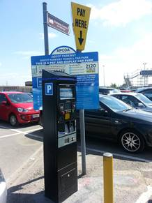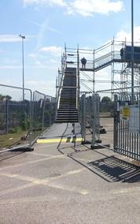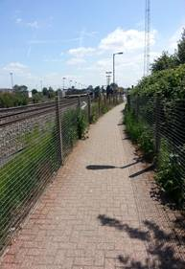

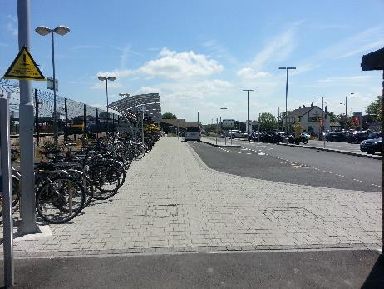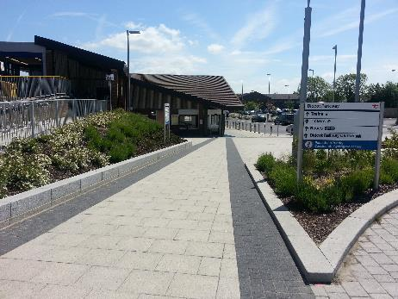

Blue Badge parking at Didcot Parkway Station

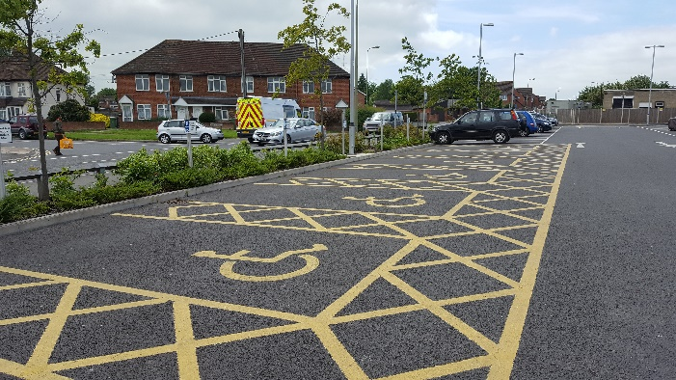

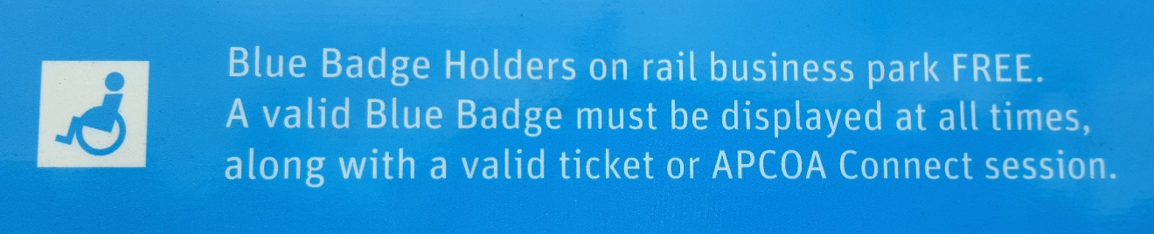

Through Didcot Parkway Station

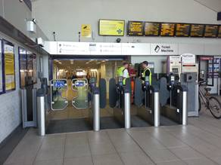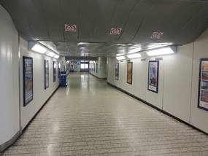

The subway and steps
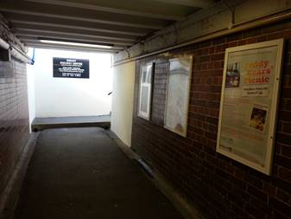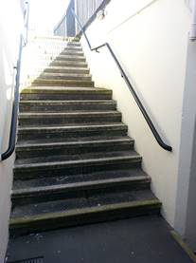

Main Entrance, Reception and Ticketing Area
- Once up the steps, the main entrance to Didcot Railway Centre is on reasonably level ground. The entrance area is paved.
- There is a seat inside the entrance.
- Wheelchairs are available free of charge.
- The Ticket Office window is open to aid visitors who lip read or have a visual impairment.
- People with disabilities pay the normal entrance rate and their carers are admitted free of charge.

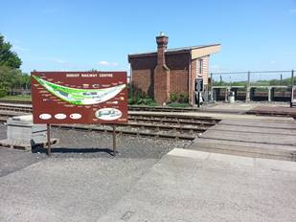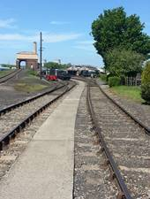

Attraction (displays, exhibits, rides etc.)
- Didcot Railway Centre is an outdoor attraction and there are level paths to the major buildings - Engine Shed, Museum & Archive, Transfer Shed, Science Learning & Railways Exhibition, Steam Rail Motor Shed, Refreshment Room, Shop and the stations. Most paths are concrete and some are compacted ash.
- The Carriage Display and Air Raid Shelter can only be accessed up or down a flight of steps, although there may be access to view carriages from ground level in the workshop area.
- There is a trail (Archie Trail) that provides a level access route around the Centre with interpretation boards in large text.
- We encourage our visitors to get up close and personal with the engines in the Engine Shed and visitors can climb the steps up to the footplate of two engines in the Engine Shed.
- The displays in the Museum & Archive are behind glass and most are visible from a wheelchair.
- On busy days (e.g. Day out With Thomas), we have to limit access for prams and pushchairs to the Science, Learning & Railways Exhibition due to lack of space.
Public Toilets
- Public toilets (Ladies, Gents and Accessible) are situated close to the Enquiry Office near the middle of the Centre and there is an additional Gents' Toilet in the Engine Shed.
- There is level access to the accessible toilet.
- The door is 38.5 inches / 980 mm wide.
- There is clear space for a wheelchair to the right of the WC. The space is 30.5 inches / 770 cm wide.
- The WC is 18 inches / 460 mm high.
- There is an emergency alarm pull cord.
- The sink has lever taps.
- The toilets are tiled and well lit with florescent tube lighting overhead.

Accessible toilet

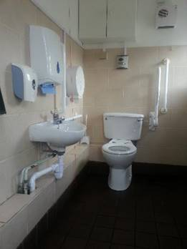

Catering
- The Refreshment Room is situated in the middle of the Centre and has step free level access from the patio area.
- The entrance doors to the Refreshment Room are 62 inches / 1570 mm wide. The second door can be opened on request.
- The tables are standard height and the chairs have no arms. There is room for wheelchair access to some of the tables.
- Tables outside the Refreshment Room in the patio area are well spaced and accessible.
- Lighting is natural daylight with overhead lighting.
- The crockery is white and contrasts with the tables and table cloths.
- The Refreshment Room is self service and staff can assist on request.
- We offer home cooked food and source some items locally. We offer a range of dietary requirements.
- The accessible toilet is approximately 50 yards (48 metres) from the Refreshment Room.
- On busy days (e.g. Day out With Thomas), we have to limit access for prams and pushchairs due to lack of space.
Shop(s)
- The shop is situated in the middle of the Centre and has step free access from the patio area.
- The door opening is 28 inches / 710 mm wide and manual.
- The shop is level throughout.
- Staff can offer assistance if required.
- There are tall display racks and low tables accessible from a seating position.
- There is a hearing loop system and staff have been trained in its use.
- On busy days (e.g. Day out With Thomas), we have to limit access for prams and pushchairs due to lack of space.

Grounds and Gardens
- The Centre is an open air site with a network of level paths. Most paths are over 1.6m wide, any narrower being relatively short and with easy passing opportunities.
- Away from the main areas there are ash and grassed paths.
- There is a grassed picnic area in the middle of the Centre where visitors can watch the trains - our own trains when we are operating and the main line passenger and freight trains when we are not.
- There are wooden benches around the Centre.

Additional Information
- Our staff receive training, including disability awareness.
- We have emergency evacuation procedures and a Duty Manager or Manager of the Day on duty on every open day.
- We welcome assistance dogs. There is a water bowl outside the Refreshment Room.

Future Plans
- We are currently working on a Heritage Lottery Fund application to improve our entrance area, including ramped access to the Centre. This work is supported by the local Didcot Access Group.

Contact Information
Address (Inc postcode): | Didcot Railway Centre Station Road Didcot Oxfordshire OX11 7NJ
Telephone: | 01235 817200
Email: | info@didcotrailwaycentre.org.uk
Website: | www.didcotrailwaycentre.org.uk
Grid Reference: | SU 52532 90504
Hours Of Operation: | 10.30 am to 4 pm (Open days and winter running days). 10.30 am to 5 pm (summer running days). Last admission is 3.30 pm.
Local Accessible Taxi: | Pryors Executive Car & Taxi 01235 812345. Note: this information is provided in good faith, no recommendations or endorsements are made.
Local Public Transport: | Didcot Parkway Station - trains from London, Reading, Oxford, Bristol and South Wales Bus services to Abingdon, Oxford, Wallingford and Wantage as well as local services in Didcot and the surrounding area.

AM/0000.doc

